**Introduction to Euclid’s Geometry**

1. A **point** is that which has no part.
2. A **line** is a breadthless length. The ends of a line are points.
3. A **straight line** is a line which lies evenly with the points on itself.
4. A **surface** is that which has length and breadth only.
5. The **edges** of a surface are lines.
6. A **plane surface** is a surface which lies evenly with the straight lines on itself.
7. Though Euclid defined **a point, a line and a plane**, but the definitions are not accepted by mathematicians. Therefore, these terms are taken as **undefined**.
8. An **axiom** is a statement accepted as true without proof, throughout mathematics.
9. A **postulate** is a statement accepted as true without proof, specifically in geometry.

# Euclid’s Axioms:

* 1. Things which are equal to the same things are equal to one another.
  2. If equals are added to equals, the wholes are equal.
  3. If equals are subtracted from equals, the remainders are equal.
  4. Things which coincide with one another are equal to one another.
  5. The whole is greater than a part.
  6. Things which are double of same things are equal to one another.
  7. Things which are halves of same things are equal to one another.

1. *A > B* means that there is some quantity *C* such that *A = B + C*.
2. **Theorems** are statements which are proved using definitions, axioms, previously proved statement and deductive reasoning.

# Euclid’s 5 Postulates:

* 1. A straight [line may be drawn from any one point to any other point.](http://mathworld.wolfram.com/LineSegment.html)
  2. A terminated [line](http://mathworld.wolfram.com/LineSegment.html) can be produced indefinitely.

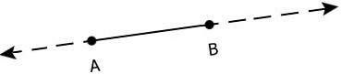

* 1. A circle can be drawn with any centre and any radius.
  2. All [right angles](http://mathworld.wolfram.com/RightAngle.html) are equal to one another.
  3. If a straight line falling on two straight lines makes the interior angles on the same side of it taken together, is less than two right angles, then the two straight lines, if produced indefinitely, meet on that side on which the sum of angles is less than two right angles.

This is known as the [parallel postulate](http://mathworld.wolfram.com/ParallelPostulate.html).

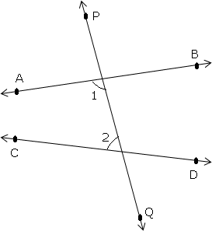

In the figure, 1 2  180. The lines AB and CD will eventually intersect on the left side of PQ.

1. Given two distinct points, there is a unique line that passes through them.
2. Two distinct lines cannot have more than one point in common.

# Equivalent version of Euclid’s fifth postulate:

* 1. For every line *l* and for every point P not lying on *l*, there exists a unique line *m* passing through P and parallel to *l*.

This result is also known as 'Playfair's Axiom'.

* 1. Two distinct intersecting lines cannot be parallel to the same line.

1. All attempts to prove Euclid’s fifth postulate using first four postulates failed and led to several other geometries called non-Euclidean geometries.
2. The distance of a point from a line is the length of the perpendicular from the point to the line.